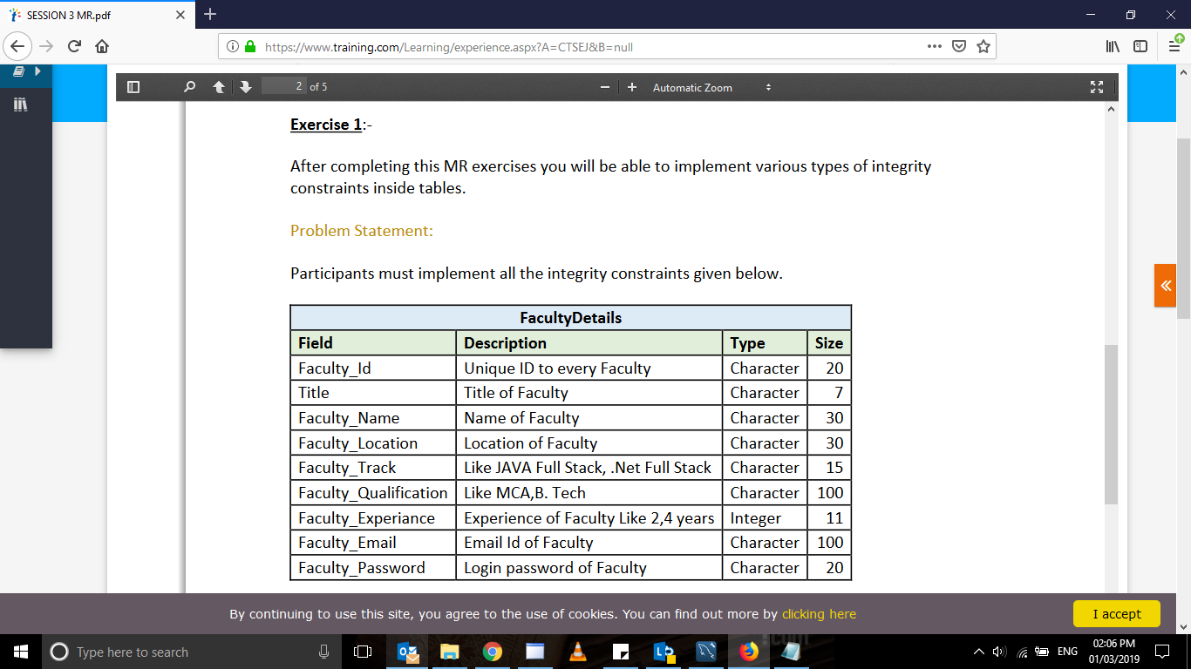

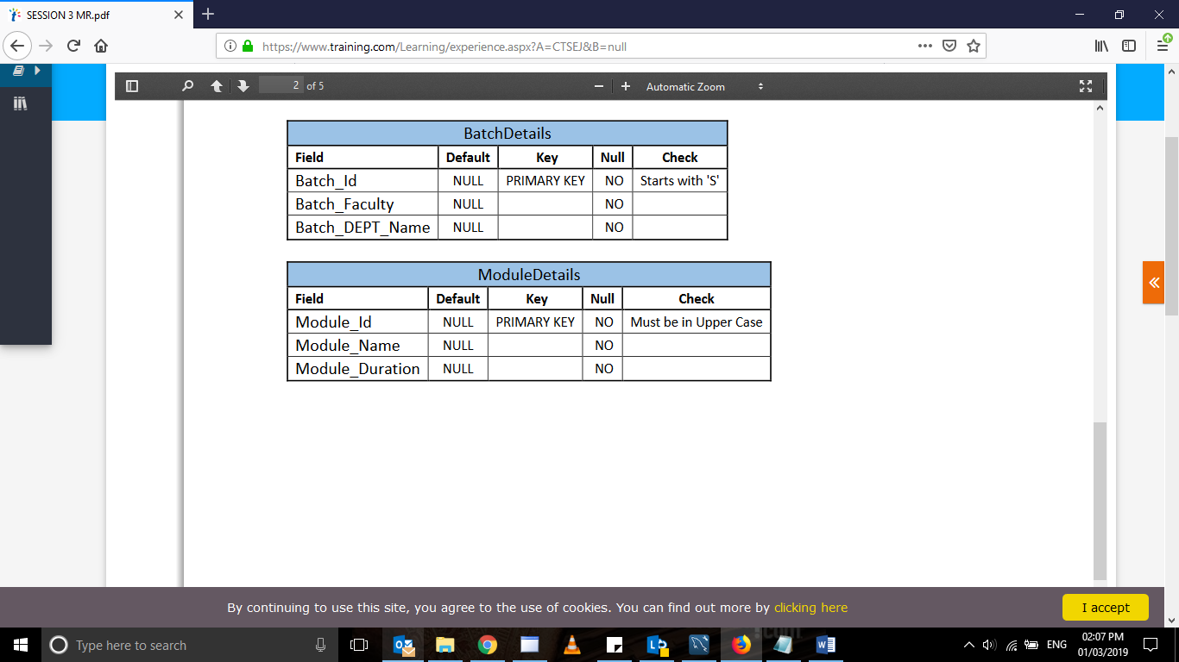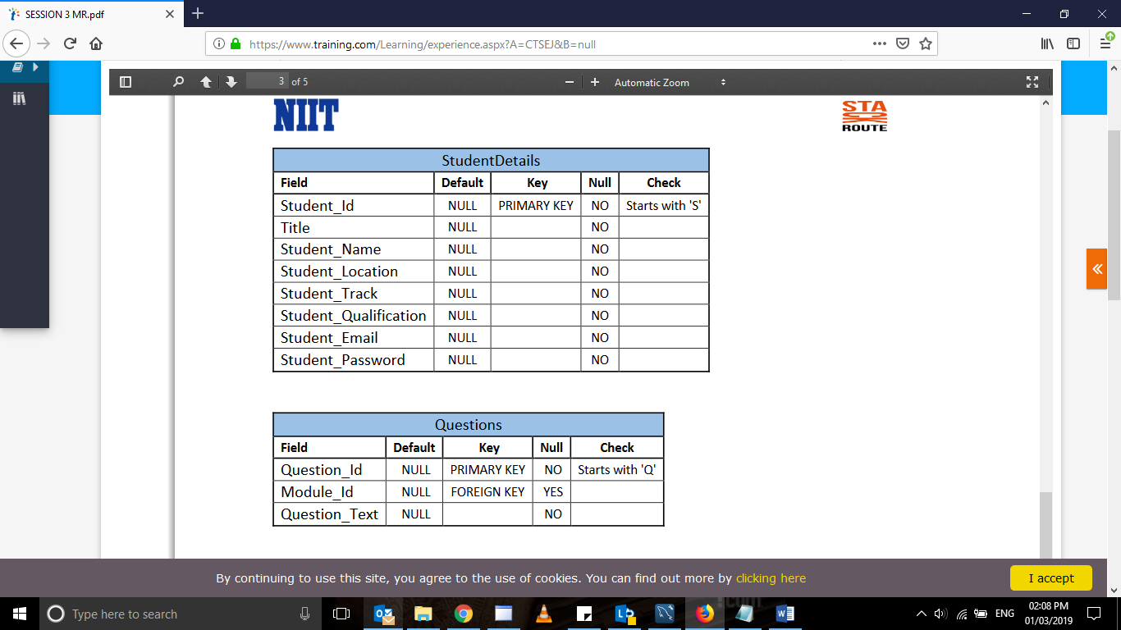

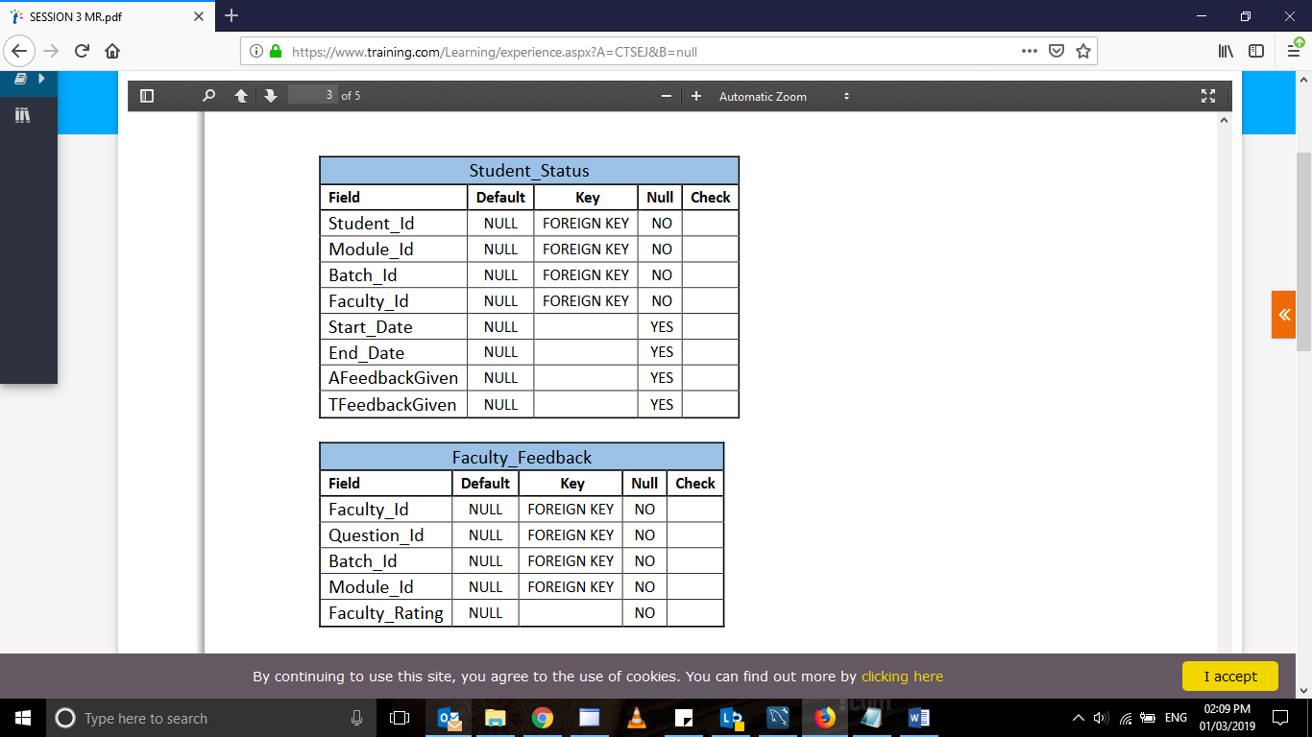

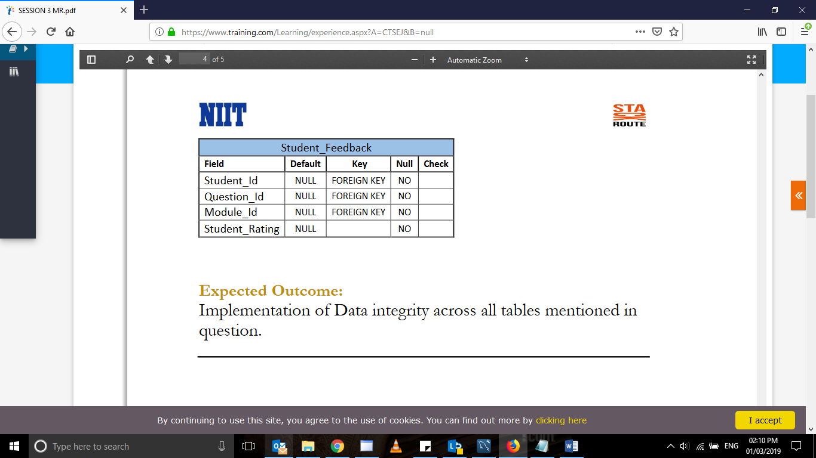

alter TABLE facultydetails

ADD  UNIQUE(faculty_id) ;

alter TABLE studentdetails

ADD  primary key(student_id) ;

alter TABLE moduledetails

ADD  primary key(module_id) ;

alter TABLE questions

ADD  primary key(question_id) ;

ALTER TABLE questions

add FOREIGN KEY (Module_ID) REFERENCES Moduledetails(module_ID);

ALTER TABLE student_status

add FOREIGN KEY (student_ID) REFERENCES studentdetail(student_ID);

ALTER TABLE student_status

add FOREIGN KEY (module_ID) REFERENCES studentdetail(module_ID);

ALTER TABLE student_status

add FOREIGN KEY (batch_ID) REFERENCES studentdetail(batch_ID);

ALTER TABLE student_status

add FOREIGN KEY (faculty_ID) REFERENCES studentdetail(faculty_ID);

ALTER TABLE faculty_feedback

add FOREIGN KEY (faculty_ID) REFERENCES questions(faculty_ID);

ALTER TABLE faculty_feedback

add FOREIGN KEY (question_ID) REFERENCES questions(question_ID);

ALTER TABLE faculty_feedback

add FOREIGN KEY (batch_ID) REFERENCES questions(batch_ID);

ALTER TABLE faculty_feedback

add FOREIGN KEY (module_ID) REFERENCES questions(module_ID);

ALTER TABLE student_feedback

add FOREIGN KEY (student_ID) REFERENCES  studentdetail(student_ID);

ALTER TABLE student_feedback

add FOREIGN KEY (question_ID) REFERENCES studentdetail(question_ID);

ALTER TABLE student_feedback

add FOREIGN KEY (module_ID) REFERENCES studentdetail(question_ID);

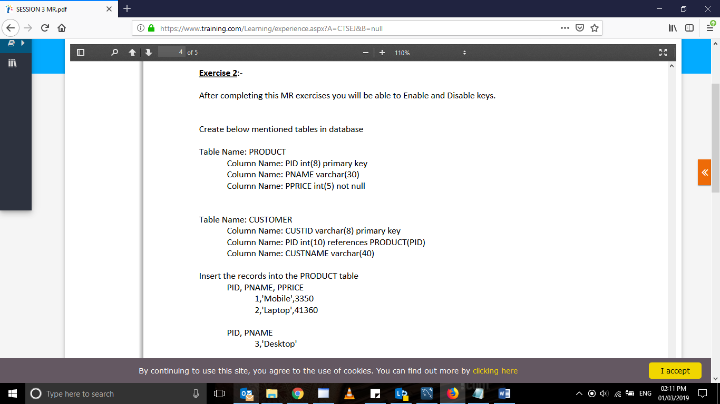

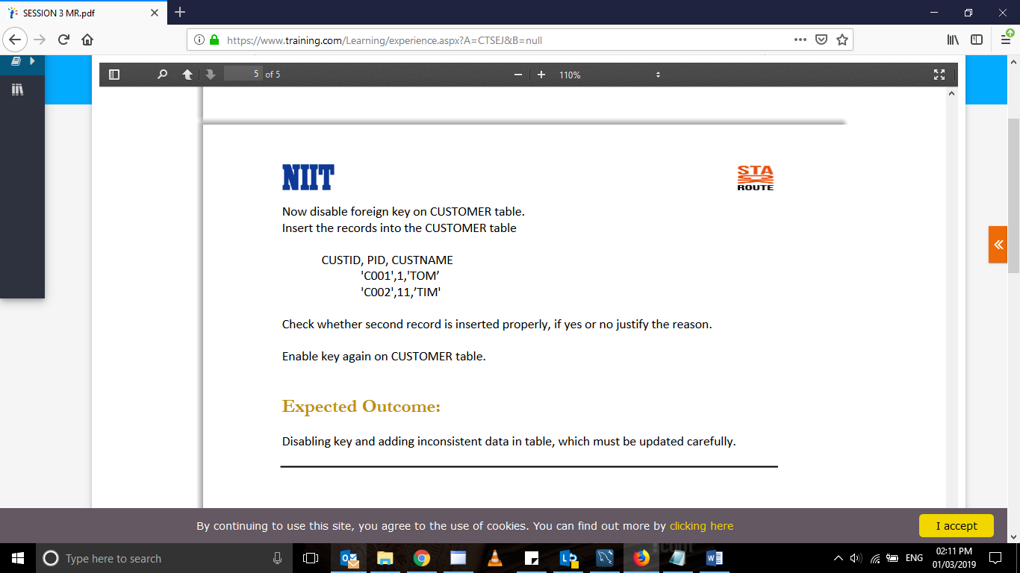

Create table product(PID int(8) primary key, PNAME varchar(30),PPRICE int(5) not null);

Create table customer (custid  varchar(8) primary key, PID int(10) references product(PID),Custname varchar(40));

 insert into product values(1,'Mobile',3350);

insert into product values(2,'Mobile',41360);

insert into product values(3,'Desktop',null);

alter table customer

drop foreign key(product(PID));